# The Ones Who Perished (part 1 of 2): The Fate of the People of Noah, Sheba, Iram and Salih

**“Each one of them We seized for their crime: against some We sent a violent tornado, some were caught by a mighty blast; some we caused the earth to swallow up, and some We drowned It was not God Who wronged them, but they who wronged themselves.” (Quran 29:40)**

## Noah and the Ark

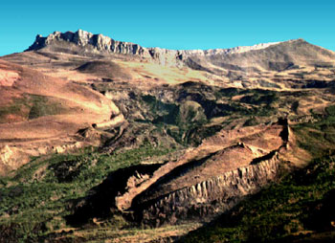

An archeological study found the above 500 foot-long boat-shaped formation atop Mount Judi[[1]](http://www.islamreligion.com/articles/282/" \l "_ftn23152" \o ), some 20 miles south of Mount Ararat (where the Bible places the Noah’s Ark).  It has horizontal deck-support timbers at consistent intervals and evenly-spaced indentations resembling decaying rib timbers.  Natural causes do not make such symmetrical formations!

**“And it was said: ‘O earth!  Swallow up your water,’ and ‘O sky!  Withhold (your rain).’  And it was said: And the water was made to subside, and God’s Decree was fulfilled.  And it (Noah’s Ark) came to rest upon (Mount) Judi...” (Quran 11:44)**

All the wicked peoples of the earth were drowned while believer and beast were carried with Noah in his Ark.  The ship remained intact upon Judi right until the dawn of Islam.  What has remained today is still a thing to behold.

## The Temple at Sheba

Another people whose sins were answered with a devastating flood were the People of Saba’ (Sheba).  They turned away from the Creator, God, to worship others.  Now, all that remains of their once prosperous civilization (at Marib, Yemen) are the broken sluices of their dam, some Sabaean inscriptions, and the ruins of their temple.[[2]](http://www.islamreligion.com/articles/282/" \l "_ftn23153" \o )  (below).

**“Indeed, there was a sign for Sheba in their dwelling place: two gardens on the right and on the left.  (It was said to them,) ‘Eat of the provision of your Lord, and be grateful to Him, a fair land and an Oft-Forgiving Lord.’  But they turned away (from God and became corrupted).  So We sent against them the unleashed dam waters, and converted their gardens into gardens bearing bitter fruit and tamarisks, and a meager few lote-trees.  That is how We rewarded them because they were ungrateful.  And never do We reward in such a way except those who are ungrateful.” (Quran 34:15-17)**

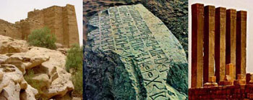

## Ad, Iram, and Ubar

**Did you not see how your Lord dealt with ‘Ad - (the people of) Iram of the pillars - the like of whom had not been created in the land (before)? (Quran 89:6-9)**

The ‘Ad were a nation of giants.  **‘Who is mightier than us in strength?!’**(Quran 41:15), they would boast, tyrannizing people with their huge size while the Prophet Hud would command them to fear God and be righteous.  For most historians, the story of Iram[[3]](http://www.islamreligion.com/articles/282/" \l "_ftn23154" \o )  was pure fable, a myth, an ‘Atlantis of the Sands.’

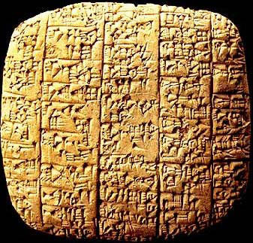

Until 1973, that is, when the 4,300 year-old city of Ebla was excavated in northern Syria.  Some 2,500 cuneiform clay tablets (above)were recovered from Ebla’s palace library, containing records of all the nations Ebla traded with, including one called ‘Iram’![[4]](http://www.islamreligion.com/articles/282/" \l "_ftn23155" \o )

**“(Hud said to ‘Ad,) ‘Do you build monuments on every high place for amusement, and take yourselves palaces as if you will live therein forever?” (Quran 26:128-129)**

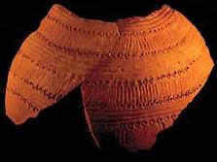

In 1992, using satellite images, the relics of a city correlating with the Quranic location and description of Iram were discovered deep beneath the desert on the edge of Oman.  The city’s wealth was evidenced by frankincense burners, Parthian pottery (above)and the 90cm-thick walls guarding them.

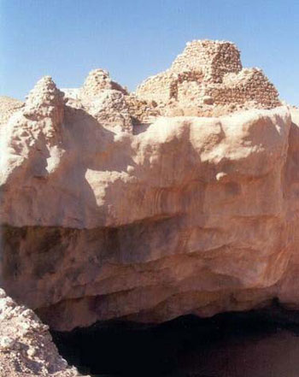

Excavations also showed that the city met with a catastrophic end when it half-collapsed into a giant sinkhole, above which the ruins of a fortress and eight once-towering pillars still stand (above).  The ‘Ad were destroyed by a force of nature even fiercer than themselves.[[5]](http://www.islamreligion.com/articles/282/" \l "_ftn23156" \o )

**“So We sent to them a ferocious wind in evil days; that We might give them a taste of disgracing punishment in this world.  And the punishment of the Hereafter is more disgracing, and they will not be helped.” (Quran 41:16)**

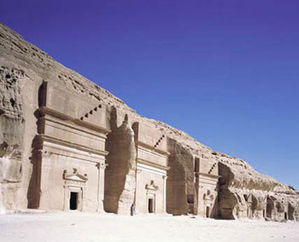

## The People of Thamud

**“(Salih said to Thamud,) ‘Will you remain secure in what you have here?  In gardens and springs, well-tilled fields and date- palms heavy with fruit; and while you hew dwellings out of mountains with such great skill?” (Quran 26:146-149)**

**“And to Thamud (We sent) their brother (Prophet) Salih.  He said: ‘O my people!  Worship God, you have no god (in truth) but Him.  He brought you forth from the earth and settled you therein.  So ask forgiveness of Him and turn to Him in repentance.  Certainly, my Lord is Near, Responsive.’  They said: ‘O Salih!  You had been among us as a figure of hope (as a future leader) till this (calling of yours to monotheism)!  Do you (now) forbid us the worship of what our fathers worshipped?  We are indeed in doubt as to that to which you invite us.” (Quran 11:61-2)**

Prophet Muhammad passed by the ghost town of Madain Salih **[ABOVE & BELOW]**, cut from mountain rock by Thamud, saying:

**“Do not enter except that you are weeping, for this was a place of (divine) punishment.”**

Kindred to the Nabateans of Petra some 300 miles to their north, Thamud violently rejected Prophet Salih.  So God struck them with a sonic blast that killed them, but spared their homes:  A truly eerie sign for later generations.

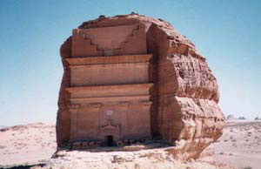

**Footnotes:**

[[1]](http://www.islamreligion.com/articles/282/" \l "_ftnref23152" \o "Back to the refrence of this footnote) “‘Arkologists’ claim to have found Noah‘s Ark“, Martin Wroe.  *The Observer* (London) 16 Jan 1994.

[[2]](http://www.islamreligion.com/articles/282/" \l "_ftnref23153" \o "Back to the refrence of this footnote) (http://www.yobserver.com/cgi-bin/yobserver/exec/view.cgi/1/8902), (http://www.viewzone.com/sheba.country.html), (http://www.ucalgary.ca/UofC/events/unicomm/NewsReleases/queen.htm)

[[3]](http://www.islamreligion.com/articles/282/" \l "_ftnref23154" \o "Back to the refrence of this footnote) Also known as Ubar.

[[4]](http://www.islamreligion.com/articles/282/" \l "_ftnref23155" \o "Back to the refrence of this footnote) *Ebla: A Revelation in Archaeology*, Times Books, 1979, Wiedenfeld and Nicolson, Great Britain.

[[5]](http://www.islamreligion.com/articles/282/" \l "_ftnref23156" \o "Back to the refrence of this footnote) Around A.D. 300, a city called Ubar—a bustling center along the frankincense trade routes of ancient Arabia - mysteriously disappeared.  According to legend, the people of Ubar became greedy and corrupt, refusing to change their ways.  To punish them, God destroyed the city and erased all roads leading to it.  Ubar was lost for thousands of years, but the legend lived on in Bedouin campfire stories, the Quran, and Arabian Nights.  Many archaeologists believed the legend of Ubar was more than a tale, but searches for the lost city came up empty.  That is, until the 1990s when NASA satellites and radar aided the hunt.  NASA’s help proved to be the key to locating Ubar.  Images from Landsat and SPOT (Satellite Pour l‘Observation de la Terre) remote sensing satellites showed tracks through the desert, identified as old caravan routes.  These tracks converged at the village Al Shisr in the southwestern corner of Oman.  An expedition followed the tracks to the virtual “X” in the sand and began digging.  Discoveries of ancient pottery shards from distant lands, frankincense burners, and remains of a fortress confirmed the archaeologists’ suspicions—Ubar was real and its demise could be explained.  Indeed, the legend was right: Ubar met a catastrophic end.  Excavation revealed a giant limestone cavern beneath the fortress.  The city most likely was destroyed when a large portion of it collapsed into the chamber below.  Today, excavations continue to discover more about life along the frankincense road over 4,000 years ago. (by Marisa Larson, *National Geographic Magazine*, http://magma.nationalgeographic.com/ngm/0304/feature2/index.html)

# (part 2 of 2): The People of Moses and Lot

**“Pharaoh said: ‘O Haman!  Build me a high tower that I may attain the means, the means of (reaching) the heavens; so that I may look to the God of Moses, for I do reckon him to be a liar!...” (Quran 40:36-37)**

For well over a thousand years, the only ‘Haman’ that was mentioned outside Islamic texts was a Babylonian courtier from the story of the Tower of Babel.  Academics derided his mention in the Quran, citing it as proof of Muhammad’s supposedly inaccurately borrowing from the bible; mixing up the Babylonian legend with the much earlier story of the Exodus.

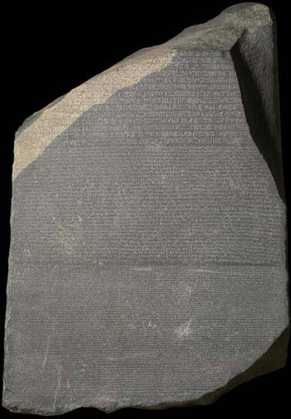

Then, in 1799, one of Napoleon’s captains in Egypt discovered a dark grey-pinkish granite stone (above) in the port city of Rosetta.  He showed it to General Abdullah Jacques de Menou, a convert to Islam, who sent it off to Cairo to be studied.  The Rosetta Stone, which dated back to 196 BC, was inscribed in three scripts: Hieroglyphic, Demotic and Greek.  Its discovery meant that scholars the world over were finally able to decipher Egyptian hieroglyphs.  One result was the decoding of an inscription on a Pharaonic stela from the Mosaic period in Vienna’s Hof-Museum.  Curiously, the name ‘Haman’ was inscribed on the stela[[1]](http://www.islamreligion.com/articles/281/" \l "_ftn10272" \o " Walter Wreszinski, Aegyptische Inschriften aus dem K.K. Hof Museum in Wien, 1906, J. C. Hinrichs' sche Buchhandlung.), his given title: ‘chief of the stone quarry workers.’[[2]](http://www.islamreligion.com/articles/281/" \l "_ftn10273" \o " Hermann Ranke, Die Ägyptischen Personennamen, Verzeichnis der Namen, Verlag Von J. J. Augustin in Glückstadt, Band I, 1935, Band II, 1952.)  Precisely the man whom a Pharaoh would ask to build a high tower!

**“And (We punished) Korah, Pharaoh and Haman.  And indeed Moses came to them with Clear Signs.  But they sought greatness in the land, while they could not outreach (the wrath from) Us.” (Quran 29:39)**

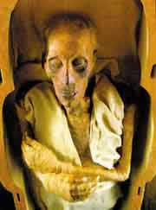

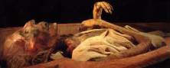

**“So this day We shall deliver your body (from the sea) that you (Pharaoh) may be a sign to those who come after you!  And verily, many among mankind are heedless of Our Signs.” (Quran 10:92)****[[3]](http://www.islamreligion.com/articles/281/" \l "_ftn10274" \o " The above pictures are those of an Egyptian mummy, supposed to be that of the Pharaoh drowned in the Red Sea. For further studies: Mummies of the Pharaohs: Modern Medical Investigations. By Maurice Bucaille. Translated by Alastair D. Pannell and the author. Illustrated. 236 pp. New York: St. Martin's Press.)**

**“And We turned (the cities of Sodom) upside down and rained down upon them stones of baked clay.  Surely, in this are signs for those who perceive.  And, verily, they were right on the road (from Mecca to Syria, where the Dead Sea is now).  Surely, therein is indeed a sign for the believers.” (Quran 15:74-77)**

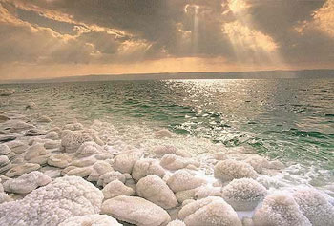

Prophet Lot was harmed by his people as he warned them against their homosexuality and oppression.  Until, finally, God rained missiles of baked clay upon the Sodomites; lifting their land up from underneath them and throwing it upside-down upon them.  The waters of the Dead Sea (above) filled the huge cavity that was left in the wake of the terrible destruction.  Today, only a few ruins (below) remain from the peoples who once thrived in the land.  A land that the sins of the Sodomites made into the lowest point on the face of the earth - in more ways than one!

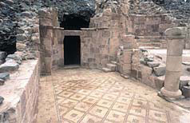

So read the Quran and take lesson from the stories of nations past; those who reached the pinnacle of civilization, amassing great wealth, power and prestige, only to be ungrateful and forget themselves and their Lord.  They became decadent and corrupt, arrogant and haughty, cruel and oppressive, as they turned to falsehoods and false gods.  God sent to them His Prophets, supported with miracles and revelation, to remind them of His Favors and to be dutiful to Him, and to be just and compassionate amongst themselves and creation at large.  But they disbelieved in spite of His Clear Signs.  They rejected their Prophets, mocked, scorned and abused them, even tried to kill them!

Finally, when they left neither hope nor excuse for themselves; when they hastened their own destruction by daring the One God to punish them; He did just that, and the earth was cleansed.  Not only do their relics serve as an admonition for us today, they also prove the divine origin of the Quran itself.  For none but a true Prophet of God, as Muhammad truly was, could have recited such details and with such certainty, except that he was inspired from above.

**“For has the story not reached them of those before them?  The people of Noah, ‘Ad and Thamud… and the overthrown cities (of the Sodomites)?  Their Messengers came to them with clear proofs.  It was not God Who wronged them, but they who wronged themselves.” (Quran 9:70)**

**Footnotes:**

[[1]](http://www.islamreligion.com/articles/281/" \l "_ftnref10272" \o "Back to the refrence of this footnote) Walter Wreszinski, Aegyptische Inschriften aus dem K.K. Hof Museum in Wien, 1906, J. C. Hinrichs' sche Buchhandlung.

[[2]](http://www.islamreligion.com/articles/281/" \l "_ftnref10273" \o "Back to the refrence of this footnote) Hermann Ranke, Die Ägyptischen Personennamen, Verzeichnis der Namen, Verlag Von J. J. Augustin in Glückstadt, Band I, 1935, Band II, 1952.

[[3]](http://www.islamreligion.com/articles/281/" \l "_ftnref10274" \o "Back to the refrence of this footnote) The above pictures are those of an Egyptian mummy, supposed to be that of the Pharaoh drowned in the Red Sea. For further studies: Mummies of the Pharaohs: Modern Medical Investigations. By Maurice Bucaille. Translated by Alastair D. Pannell and the author. Illustrated. 236 pp. New York: St. Martin's Press.